

Mobile Application Development

Lab 7



Muhammad daniyal Qureshi

021-18-0009

BSCS-VII

Contents

**Activity 1 – Adding fragments statically** 1

**Layout** 1

**Logic Code** 3

**Output** 5

Activity 2: Dynamic Fragements 6

**Layout** 6

**Logic Code** 9

**Output** 14

Activity 3: Friends App (Fragments) 16

**Layout** 16

**Logic Code** 21

**Output** 27

Activity 4: Fake Twitter 27

**Layout** 28

**Logic Code** 29

**Output** 32

Activity 5: Hangman (Speak to text and text to speech feature) 35

**Layout** 35

**Logic Code** 37

**Output** 42

## Activity 1 – Adding fragments statically

## **Layout**

<?xml version="1.0" encoding="utf-8"?>

<LinearLayout xmlns:android="http://schemas.android.com/apk/res/android"

    xmlns:app="http://schemas.android.com/apk/res-auto"

    xmlns:tools="http://schemas.android.com/tools"

    android:layout_width="match_parent"

    android:layout_height="match_parent"

    tools:context=".MainActivity">

    <fragment

        android:id="@+id/fragment"

        android:name="com.example.fragement_activity.fragement1"

        android:layout_width="0dp"

        android:layout_height="match_parent"

        android:layout_weight="1" />

    <fragment

        android:id="@+id/fragment2"

        android:name="com.example.fragement_activity.fragement2"

        android:layout_width="0dp"

        android:layout_height="match_parent"

        android:layout_weight="1" />

</LinearLayout>

<?xml version="1.0" encoding="utf-8"?>

<FrameLayout xmlns:android="http://schemas.android.com/apk/res/android"

    xmlns:tools="http://schemas.android.com/tools"

    android:layout_width="match_parent"

    android:layout_height="match_parent"

    tools:context=".fragement1">

    <TextView

        android:layout_width="wrap_content"

        android:layout_height="wrap_content"

        android:text="Fragement 1 "

        android:textSize="40sp"

        android:textColor="@color/design_default_color_primary"

        />

</FrameLayout>

<?xml version="1.0" encoding="utf-8"?>

<FrameLayout xmlns:android="http://schemas.android.com/apk/res/android"

    xmlns:tools="http://schemas.android.com/tools"

    android:layout_width="match_parent"

    android:layout_height="match_parent"

    tools:context=".fragement2">

    <TextView

        android:layout_width="wrap_content"

        android:layout_height="wrap_content"

        android:text="Fragement 2 "

        android:textSize="40sp"

        android:textColor="@color/design_default_color_primary"

        />

</FrameLayout>

## **Logic Code**

package com.example.fragement_activity;

import androidx.appcompat.app.AppCompatActivity;

import androidx.fragment.app.FragmentManager;

import androidx.fragment.app.FragmentTransaction;

import android.os.Bundle;

public class MainActivity extends AppCompatActivity {

    @Override

    protected void onCreate(Bundle savedInstanceState) {

        super.onCreate(savedInstanceState);

        setContentView(R.layout.activity_main);

        FragmentManager manager=getSupportFragmentManager();

        FragmentTransaction transaction=manager.beginTransaction();

        transaction.add(R.id.fragment,new fragement1());

        transaction.add(R.id.fragment2,new fragement2());

        transaction.commit();

    }

}

package com.example.fragement_activity;

import android.os.Bundle;

import androidx.fragment.app.Fragment;

import android.view.LayoutInflater;

import android.view.View;

import android.view.ViewGroup;

public class fragement1 extends Fragment {

    @Override

    public void onCreate(Bundle savedInstanceState) {

        super.onCreate(savedInstanceState);

    }

    @Override

    public View onCreateView(LayoutInflater inflater, ViewGroup container,

                             Bundle savedInstanceState) {

        return inflater.inflate(R.layout.fragment_fragement1, container, false);

    }

}

package com.example.fragement_activity;

import android.os.Bundle;

import androidx.fragment.app.Fragment;

import android.view.LayoutInflater;

import android.view.View;

import android.view.ViewGroup;

public class fragement2 extends Fragment {

    @Override

    public void onCreate(Bundle savedInstanceState) {

        super.onCreate(savedInstanceState);

    }

    @Override

    public View onCreateView(LayoutInflater inflater, ViewGroup container,

                             Bundle savedInstanceState) {

        // Inflate the layout for this fragment

        return inflater.inflate(R.layout.fragment_fragement2, container, false);

    }

}

## **Output**

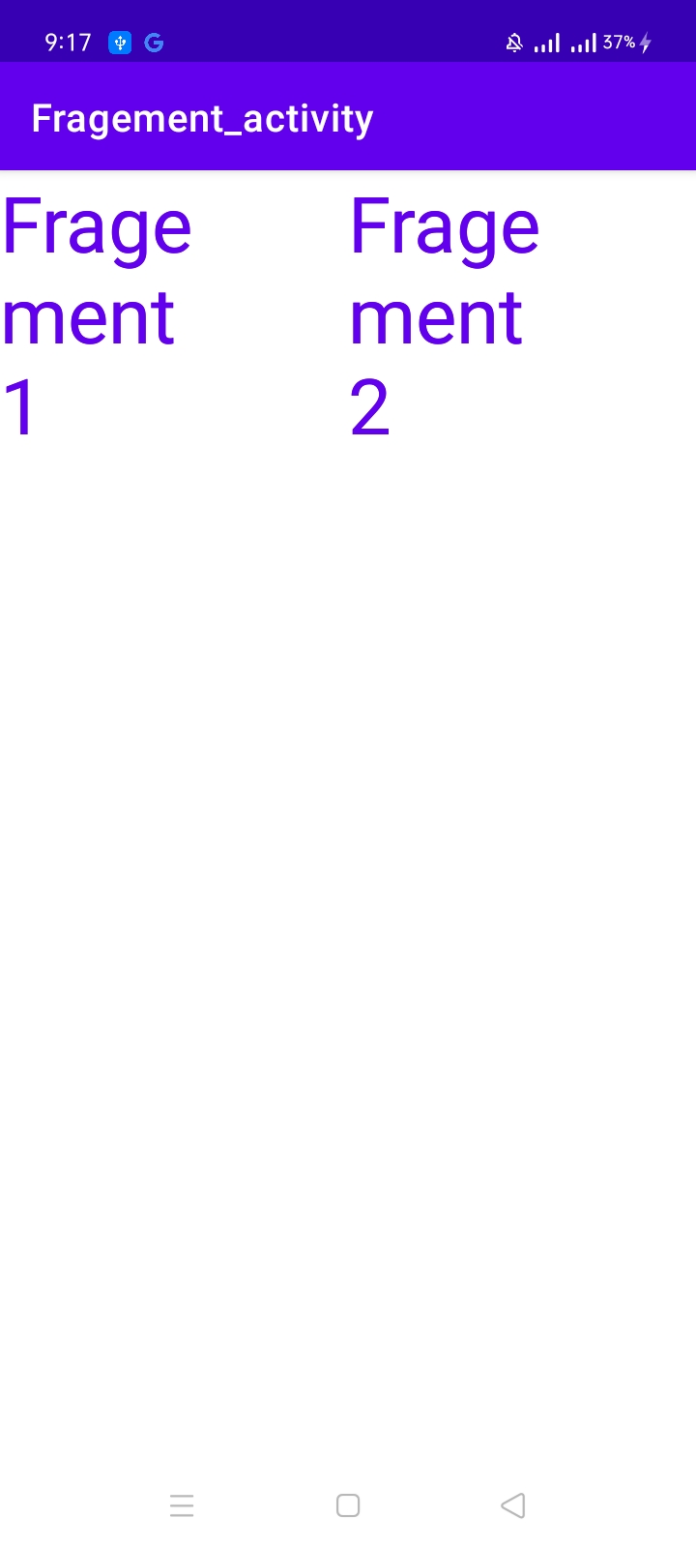

# Activity 2: Dynamic Fragements

## **Layout**

<?xml version="1.0" encoding="utf-8"?>

<LinearLayout xmlns:android="http://schemas.android.com/apk/res/android"

    xmlns:app="http://schemas.android.com/apk/res-auto"

    xmlns:tools="http://schemas.android.com/tools"

    android:layout_width="match_parent"

    android:layout_height="match_parent"

    tools:context=".MainActivity"

    android:orientation="horizontal"

    android:layout_weight="1"

    >

    <LinearLayout

        android:layout_width="wrap_content"

        android:layout_height="match_parent"

        android:orientation="vertical">

        <Button

            android:id="@+id/button1"

            android:layout_width="wrap_content"

            android:layout_height="wrap_content"

            android:text="Battery"

            android:onClick="show"

            />

        <Button

            android:id="@+id/button2"

            android:layout_width="wrap_content"

            android:layout_height="wrap_content"

            android:text="location"

            android:onClick="show"

            />

        <Button

            android:id="@+id/button3"

            android:layout_width="wrap_content"

            android:layout_height="wrap_content"

            android:text="Setting"

            android:onClick="show"

            />

        <Button

            android:id="@+id/button4"

            android:layout_width="wrap_content"

            android:layout_height="wrap_content"

            android:text="Notification"

            android:onClick="show"

            />

        <Button

            android:id="@+id/button5"

            android:layout_width="wrap_content"

            android:layout_height="wrap_content"

            android:text="Alarm"

            android:onClick="show"

            />

    </LinearLayout>

    <FrameLayout

        android:layout_width="0dp"

        android:layout_height="match_parent"

        android:layout_weight="1"

        android:id="@+id/frag"

        >

    </FrameLayout>

</LinearLayout>

<?xml version="1.0" encoding="utf-8"?>

<FrameLayout xmlns:android="http://schemas.android.com/apk/res/android"

    xmlns:tools="http://schemas.android.com/tools"

    android:layout_width="match_parent"

    android:layout_height="match_parent"

    tools:context=".alarm">

    <TextView

        android:layout_width="match_parent"

        android:layout_height="match_parent"

        android:text="Alarm Fragement Loaded"

        android:textSize="20sp"

        android:textColor="@color/teal_700"

        />

</FrameLayout>

<?xml version="1.0" encoding="utf-8"?>

<FrameLayout xmlns:android="http://schemas.android.com/apk/res/android"

    xmlns:tools="http://schemas.android.com/tools"

    android:layout_width="match_parent"

    android:layout_height="match_parent"

    tools:context=".Battery">

    <TextView

        android:layout_width="match_parent"

        android:layout_height="match_parent"

        android:text="Battery Fragement Loaded"

        android:textSize="20sp"

        android:textColor="@color/teal_700"

        />

</FrameLayout>

<?xml version="1.0" encoding="utf-8"?>

<FrameLayout xmlns:android="http://schemas.android.com/apk/res/android"

    xmlns:tools="http://schemas.android.com/tools"

    android:layout_width="match_parent"

    android:layout_height="match_parent"

    tools:context=".location">

    <TextView

        android:layout_width="match_parent"

        android:layout_height="match_parent"

        android:text="Location Fragement Loaded"

        android:textSize="20sp"

        android:textColor="@color/teal_700"

        />

</FrameLayout>

<?xml version="1.0" encoding="utf-8"?>

<FrameLayout xmlns:android="http://schemas.android.com/apk/res/android"

    xmlns:tools="http://schemas.android.com/tools"

    android:layout_width="match_parent"

    android:layout_height="match_parent"

    tools:context=".notification">

    <TextView

        android:layout_width="match_parent"

        android:layout_height="match_parent"

        android:text="Notification Fragement Loaded"

        android:textSize="20sp"

        android:textColor="@color/teal_700"

        />

</FrameLayout>

<?xml version="1.0" encoding="utf-8"?>

<FrameLayout xmlns:android="http://schemas.android.com/apk/res/android"

    xmlns:tools="http://schemas.android.com/tools"

    android:layout_width="match_parent"

    android:layout_height="match_parent"

    tools:context=".setting">

    <!-- TODO: Update blank fragment layout -->

    <TextView

        android:layout_width="match_parent"

        android:layout_height="match_parent"

        android:text="Settings Fragement Load"

        android:textSize="20sp"

        android:textColor="@color/teal_700"

        />

</FrameLayout>

## **Logic Code**

package com.example.dynamic_fragements;

import androidx.appcompat.app.AppCompatActivity;

import androidx.fragment.app.FragmentManager;

import androidx.fragment.app.FragmentTransaction;

import android.os.Bundle;

import android.view.View;

import android.widget.Button;

public class MainActivity extends AppCompatActivity {

    FragmentTransaction transaction;

    FragmentManager manager;

    @Override

    protected void onCreate(Bundle savedInstanceState) {

        super.onCreate(savedInstanceState);

        setContentView(R.layout.activity_main);

         manager=getSupportFragmentManager();

        transaction=manager.beginTransaction();

    }

    public void show(View view){

        Button btn = (Button)view;

        if(btn.getText().toString().equalsIgnoreCase("Setting"))

        {

            transaction=manager.beginTransaction();

            transaction.replace(R.id.frag,new setting());

            transaction.commit();

        }

       else if(btn.getText().toString().equalsIgnoreCase("Notification"))

        {

            transaction=manager.beginTransaction();

            transaction.replace(R.id.frag,new notification());

            transaction.commit();

        }

        if(btn.getText().toString().equalsIgnoreCase("Alarm"))

        {

            transaction=manager.beginTransaction();

            transaction.replace(R.id.frag,new alarm());

            transaction.commit();

        }

        if(btn.getText().toString().equalsIgnoreCase("Location"))

        {

            transaction=manager.beginTransaction();

            transaction.replace(R.id.frag,new location());

            transaction.commit();

        }

        if(btn.getText().toString().equalsIgnoreCase("Battery"))

        {

            transaction=manager.beginTransaction();

            transaction.replace(R.id.frag,new Battery());

            transaction.commit();

        }

    }

}

package com.example.dynamic_fragements;

import android.os.Bundle;

import androidx.fragment.app.Fragment;

import android.view.LayoutInflater;

import android.view.View;

import android.view.ViewGroup;

/**

 * A simple {@link Fragment} subclass.

 * Use the {@link notification#newInstance} factory method to

 * create an instance of this fragment.

 */

public class notification extends Fragment {

    // TODO: Rename parameter arguments, choose names that match

    // the fragment initialization parameters, e.g. ARG_ITEM_NUMBER

    private static final String ARG_PARAM1 = "param1";

    private static final String ARG_PARAM2 = "param2";

    // TODO: Rename and change types of parameters

    private String mParam1;

    private String mParam2;

    public notification() {

        // Required empty public constructor

    }

    /**

     * Use this factory method to create a new instance of

     * this fragment using the provided parameters.

     *

     * @param param1 Parameter 1.

     * @param param2 Parameter 2.

     * @return A new instance of fragment notification.

     */

    // TODO: Rename and change types and number of parameters

    public static notification newInstance(String param1, String param2) {

        notification fragment = new notification();

        Bundle args = new Bundle();

        args.putString(ARG_PARAM1, param1);

        args.putString(ARG_PARAM2, param2);

        fragment.setArguments(args);

        return fragment;

    }

    @Override

    public void onCreate(Bundle savedInstanceState) {

        super.onCreate(savedInstanceState);

        if (getArguments() != null) {

            mParam1 = getArguments().getString(ARG_PARAM1);

            mParam2 = getArguments().getString(ARG_PARAM2);

        }

    }

    @Override

    public View onCreateView(LayoutInflater inflater, ViewGroup container,

                             Bundle savedInstanceState) {

        // Inflate the layout for this fragment

        return inflater.inflate(R.layout.fragment_notification, container, false);

    }

}

package com.example.dynamic_fragements;

import android.os.Bundle;

import androidx.fragment.app.Fragment;

import android.view.LayoutInflater;

import android.view.View;

import android.view.ViewGroup;

public class setting extends Fragment {

    @Override

    public void onCreate(Bundle savedInstanceState) {

        super.onCreate(savedInstanceState);

    }

    @Override

    public View onCreateView(LayoutInflater inflater, ViewGroup container,

                             Bundle savedInstanceState) {

        // Inflate the layout for this fragment

        return inflater.inflate(R.layout.fragment_setting, container, false);

    }

}

package com.example.dynamic_fragements;

import android.os.Bundle;

import androidx.annotation.Nullable;

import androidx.fragment.app.Fragment;

import android.view.LayoutInflater;

import android.view.View;

import android.view.ViewGroup;

public class location extends Fragment {

    @Override

    public void onCreate(Bundle savedInstanceState) {

        super.onCreate(savedInstanceState);

    }

    @Override

    public View onCreateView(LayoutInflater inflater, ViewGroup container,

                             Bundle savedInstanceState) {

        // Inflate the layout for this fragment

        return inflater.inflate(R.layout.fragment_location, container, false);

    }

    @Override

    public void onActivityCreated(@Nullable Bundle savedInstanceState) {

        super.onActivityCreated(savedInstanceState);

   }

}

## **Output**

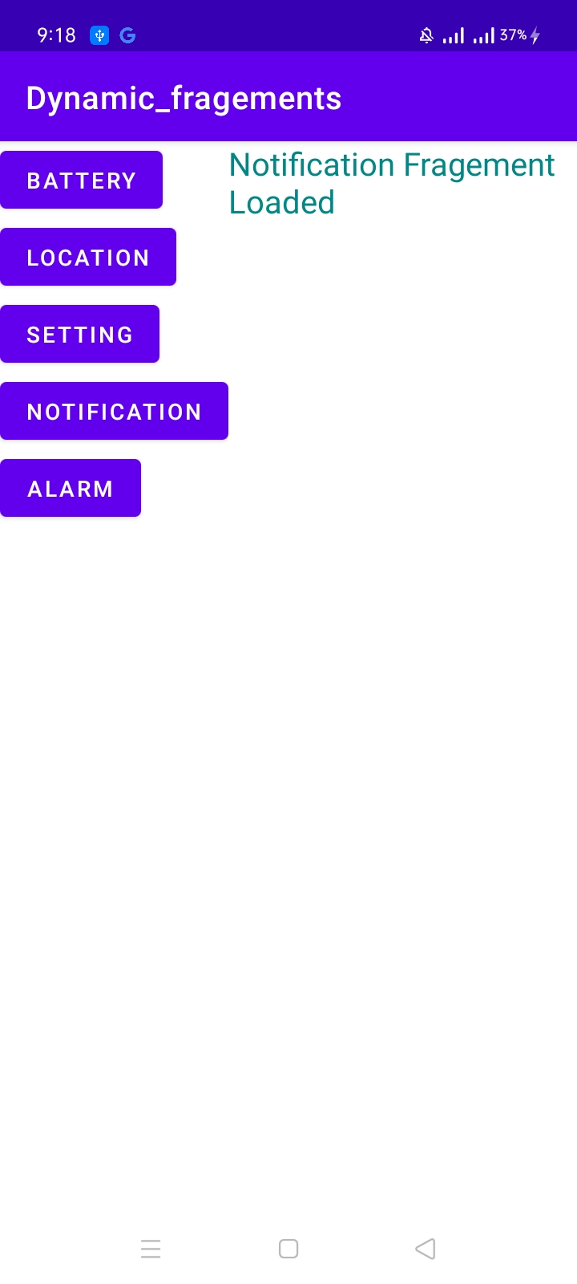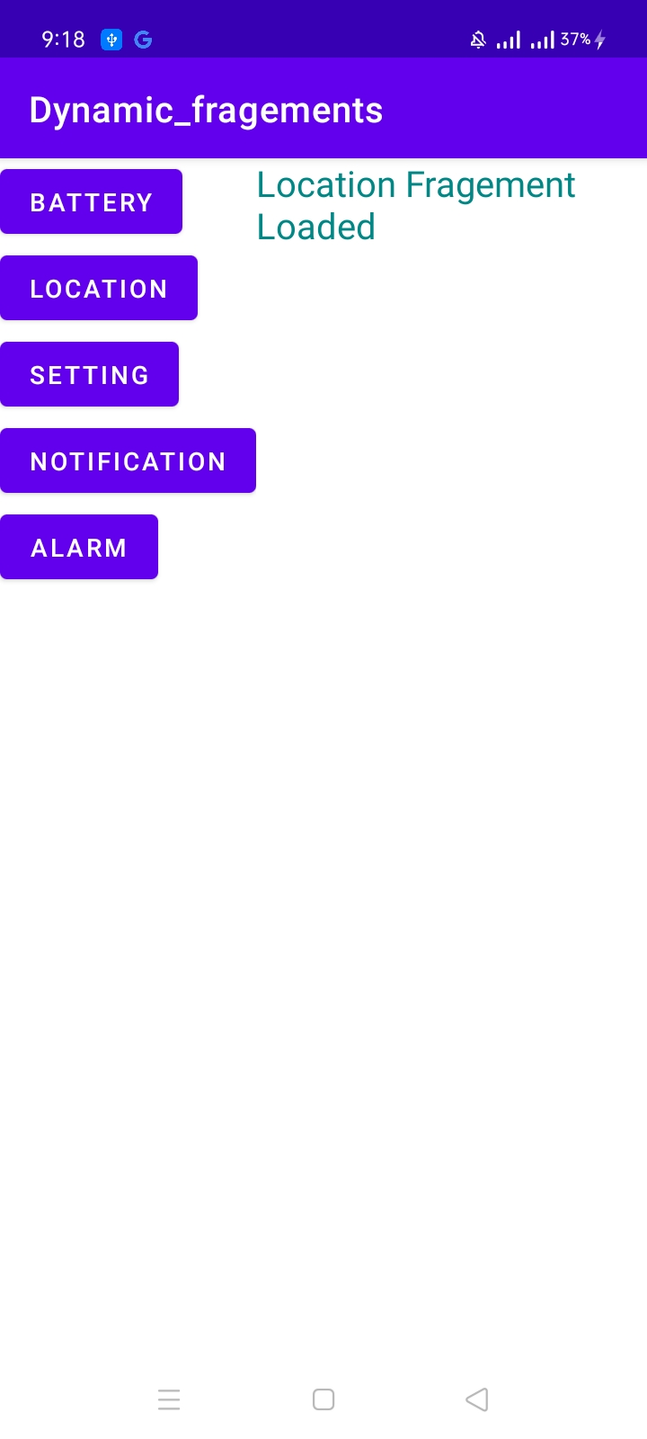

# Activity 3: Friends App (Fragments)

## **Layout**

<?xml version="1.0" encoding="utf-8"?>

<LinearLayout xmlns:android="http://schemas.android.com/apk/res/android"

    xmlns:app="http://schemas.android.com/apk/res-auto"

    xmlns:tools="http://schemas.android.com/tools"

    android:layout_width="match_parent"

    android:layout_height="match_parent"

    tools:context=".MainActivity">

<FrameLayout

    android:layout_width="match_parent"

    android:layout_height="match_parent"

    android:id="@+id/fragement"

    ></FrameLayout>

</LinearLayout>

<?xml version="1.0" encoding="utf-8"?>

<FrameLayout xmlns:android="http://schemas.android.com/apk/res/android"

    xmlns:tools="http://schemas.android.com/tools"

    android:layout_width="match_parent"

    android:layout_height="match_parent"

    tools:context=".details">

    <ScrollView

        android:layout_width="match_parent"

        android:layout_height="match_parent"

        android:scrollbarSize="25sp"

        >

        <LinearLayout

            android:layout_width="match_parent"

            android:layout_height="match_parent"

            android:orientation="vertical"

            tools:context=".Details"

            android:padding="10dp"

            >

            <RatingBar

                android:id="@+id/rating"

                android:layout_width="wrap_content"

                android:layout_height="wrap_content"

                android:layout_gravity="center"

                android:numStars="5" />

            <ImageView

                android:id="@+id/imageView"

                android:layout_width="wrap_content"

                android:layout_height="wrap_content"

                android:layout_gravity="center"

                tools:srcCompat="@tools:sample/avatars" />

            <TextView

                android:id="@+id/txt"

                android:layout_width="wrap_content"

                android:layout_height="wrap_content"

                android:layout_gravity="center"

                android:text="TextView"

                android:textSize="24sp" />

        </LinearLayout>

    </ScrollView>

</FrameLayout>

<?xml version="1.0" encoding="utf-8"?>

<FrameLayout xmlns:android="http://schemas.android.com/apk/res/android"

    xmlns:tools="http://schemas.android.com/tools"

    android:layout_width="match_parent"

    android:layout_height="match_parent"

    xmlns:app="http://schemas.android.com/apk/res-auto"

    tools:context=".main">

    <LinearLayout

        android:layout_width="match_parent"

        android:layout_height="match_parent"

        android:orientation="vertical">

        <TextView

            android:id="@+id/textView"

            android:layout_width="wrap_content"

            android:layout_height="wrap_content"

            android:layout_gravity="center"

            android:layout_weight="0"

            android:text="Friends"

            android:textSize="26sp"

            android:textStyle="bold" />

        <TextView

            android:id="@+id/textView2"

            android:layout_width="match_parent"

            android:layout_height="wrap_content"

            android:layout_weight="0"

            android:text="Click on an eligible single user to learn more and see if you are compatible  for a date!"

            android:textSize="18sp" />

        <LinearLayout

            android:layout_width="match_parent"

            android:layout_height="wrap_content"

            android:layout_weight="0"

            android:orientation="horizontal">

            <LinearLayout

                android:layout_width="match_parent"

                android:layout_height="match_parent"

                android:layout_marginStart="20dp"

                android:layout_marginLeft="20dp"

                android:layout_weight="1"

                android:gravity="center"

                android:orientation="vertical">

                <ImageButton

                    android:id="@+id/ImageButton"

                    android:layout_width="wrap_content"

                    android:layout_height="wrap_content"

                    app:srcCompat="@drawable/chandlersmall"

                    android:tag="1"

                    />

                <TextView

                    android:id="@+id/textView3"

                    android:layout_width="wrap_content"

                    android:layout_height="wrap_content"

                    android:text="Chandler" />

                <ImageButton

                    android:id="@+id/ImageButton3"

                    android:layout_width="wrap_content"

                    android:layout_height="wrap_content"

                    app:srcCompat="@drawable/monicasmall"

                    android:tag="2"

                    />

                <TextView

                    android:id="@+id/textView4"

                    android:layout_width="wrap_content"

                    android:layout_height="wrap_content"

                    android:text="Monica" />

                <ImageButton

                    android:id="@+id/ImageButton4"

                    android:layout_width="wrap_content"

                    android:layout_height="wrap_content"

                    app:srcCompat="@drawable/rachelsmall"

                    android:tag="3"

                    />

                <TextView

                    android:id="@+id/textView5"

                    android:layout_width="wrap_content"

                    android:layout_height="wrap_content"

                    android:text="Rachel" />

            </LinearLayout>

            <LinearLayout

                android:layout_width="match_parent"

                android:layout_height="match_parent"

                android:layout_marginEnd="20dp"

                android:layout_marginRight="20dp"

                android:layout_weight="1"

                android:gravity="center"

                android:orientation="vertical">

                <ImageButton

                    android:id="@+id/ImageButton2"

                    android:layout_width="wrap_content"

                    android:layout_height="wrap_content"

                    android:tag="4"

                    app:srcCompat="@drawable/joeysmall"

                    />

                <TextView

                    android:id="@+id/textView6"

                    android:layout_width="wrap_content"

                    android:layout_height="wrap_content"

                    android:text="Joey" />

                <ImageButton

                    android:id="@+id/ImageButton5"

                    android:layout_width="wrap_content"

                    android:layout_height="wrap_content"

                    android:tag="5"

                    app:srcCompat="@drawable/phoebesmall"

                    />

                <TextView

                    android:id="@+id/textView7"

                    android:layout_width="wrap_content"

                    android:layout_height="wrap_content"

                    android:text="Phoebe" />

                <ImageButton

                    android:id="@+id/ImageButton6"

                    android:layout_width="wrap_content"

                    android:layout_height="wrap_content"

                    android:tag="6"

                    app:srcCompat="@drawable/rosssmall"

                    android:onClick="click"

                    />

                <TextView

                    android:id="@+id/textView8"

                    android:layout_width="wrap_content"

                    android:layout_height="wrap_content"

                    android:text="Ross" />

            </LinearLayout>

        </LinearLayout>

    </LinearLayout>

</FrameLayout>

## **Logic Code**

package com.example.friends_app_fragements;

import androidx.appcompat.app.AppCompatActivity;

import androidx.fragment.app.FragmentManager;

import androidx.fragment.app.FragmentTransaction;

import android.os.Bundle;

public class MainActivity extends AppCompatActivity {

    FragmentTransaction transaction;

    FragmentManager manager;

    @Override

    protected void onCreate(Bundle savedInstanceState) {

        super.onCreate(savedInstanceState);

        setContentView(R.layout.activity_main);

        manager=getSupportFragmentManager();

        transaction=manager.beginTransaction();

        transaction.add(R.id.fragement,new main());

        transaction.commit();

    }

}

package com.example.friends_app_fragements;

import android.os.Bundle;

import androidx.annotation.Nullable;

import androidx.fragment.app.Fragment;

import androidx.fragment.app.FragmentManager;

import androidx.fragment.app.FragmentTransaction;

import android.util.Log;

import android.view.LayoutInflater;

import android.view.View;

import android.view.ViewGroup;

import android.widget.Button;

import android.widget.ImageButton;

import android.widget.Toast;

public class main extends Fragment implements  View.OnClickListener{

    @Override

    public void onCreate(Bundle savedInstanceState) {

        super.onCreate(savedInstanceState);

    }

    @Override

    public View onCreateView(LayoutInflater inflater, ViewGroup container,

                             Bundle savedInstanceState) {

    Bundle bundle=getArguments();

    if(bundle!=null) {

        Toast.makeText(getActivity(), "You have rated" + bundle.getFloat("rating"), Toast.LENGTH_LONG).show();

    }

    //Log.i("ra",bundle.getFloat("rating")+"");

        return inflater.inflate(R.layout.fragment_main, container, false);

    }

    @Override

    public void onActivityCreated(@Nullable Bundle savedInstanceState) {

        super.onActivityCreated(savedInstanceState);

        ImageButton btn=getActivity().findViewById(R.id.ImageButton);

        btn.setOnClickListener(this);

        btn=getActivity().findViewById(R.id.ImageButton2);

        btn.setOnClickListener(this);

        btn=getActivity().findViewById(R.id.ImageButton3);

        btn.setOnClickListener(this);

        btn=getActivity().findViewById(R.id.ImageButton4);

        btn.setOnClickListener(this);

        btn=getActivity().findViewById(R.id.ImageButton5);

        btn.setOnClickListener(this);

        btn=getActivity().findViewById(R.id.ImageButton6);

        btn.setOnClickListener(this);

    }

    @Override

    public void onClick(View v) {

        ImageButton btn=(ImageButton)v;

        details details_frag=new details();

        Bundle bundle=new Bundle();

        bundle.putString("tag",btn.getTag().toString());

        details_frag.setArguments(bundle);

        getFragmentManager().beginTransaction().replace(R.id.fragement, details_frag).commit();

    }

}

package com.example.friends_app_fragements;

import android.content.Context;

import android.content.SharedPreferences;

import android.os.Bundle;

import androidx.activity.OnBackPressedCallback;

import androidx.annotation.Nullable;

import androidx.fragment.app.Fragment;

import androidx.fragment.app.FragmentManager;

import androidx.fragment.app.FragmentTransaction;

import android.util.Log;

import android.view.KeyEvent;

import android.view.LayoutInflater;

import android.view.View;

import android.view.ViewGroup;

import android.widget.ImageView;

import android.widget.RatingBar;

import android.widget.TextView;

public class details extends Fragment {

    String name;

    float Rating;

    TextView txt;

    @Override

    public void onCreate(Bundle savedInstanceState) {

        super.onCreate(savedInstanceState);

    }

    @Override

    public void onActivityCreated(@Nullable Bundle savedInstanceState) {

        super.onActivityCreated(savedInstanceState);

    }

    @Override

    public View onCreateView(LayoutInflater inflater, ViewGroup container,

                             Bundle savedInstanceState) {

        ViewGroup root=(ViewGroup)inflater.inflate(R.layout.fragment_details,container,false);

        String tag=getArguments().getString("tag");

        ImageView img= root.findViewById(R.id.imageView);

        txt=root.findViewById(R.id.txt);

        RatingBar ratingBar=root.findViewById(R.id.rating);

        String[] str=root.getResources().getStringArray(R.array.friend_details);

        SharedPreferences prefs=getActivity().getSharedPreferences("user", getActivity().MODE_PRIVATE);

        Rating=0;

        if(tag.equals("1"))

        {

            img.setImageResource(R.drawable.chandler);

            txt.setText(str[0]);

            name="chandler";

        }

        else if(tag.equals("2"))

        {

            img.setImageResource(R.drawable.monica);

            txt.setText(str[2]);

            name="monica";

        }

        else if(tag.equals("3"))

        {

            img.setImageResource(R.drawable.rachel);

            txt.setText(str[4]);

            name="rachel";

        }

        else if(tag.equals("4"))

        {

            img.setImageResource(R.drawable.joey);

            txt.setText(str[1]);

            name="joey";

        }

        else if(tag.equals("5"))

        {

            img.setImageResource(R.drawable.phoebe);

            txt.setText(str[3]);

            name="phoebe";

        }

        else if(tag.equals("6"))

        {

            img.setImageResource(R.drawable.ross);

            txt.setText(str[5]);

            name="ross";

        }

        String d=prefs.getString(name,"none");

        if(!d.equals("none")) {

            ratingBar.setRating(Float.parseFloat(d));

            Rating=Float.parseFloat(d);

        }

        ratingBar.setOnRatingBarChangeListener(new RatingBar.OnRatingBarChangeListener() {

            @Override

            public void onRatingChanged(RatingBar ratingBar, float rating, boolean fromUser) {

                SharedPreferences prefs=getActivity().getSharedPreferences("user",getActivity().MODE_PRIVATE);

                SharedPreferences.Editor editor=prefs.edit();

                editor.putString(name,""+rating);

                Rating=rating;

                editor.commit();

            }

        });

        root.setFocusableInTouchMode(true);

        root.requestFocus();

        root.setOnKeyListener(new View.OnKeyListener() {

            @Override

            public boolean onKey(View v, int keyCode, KeyEvent event) {

                if (keyCode == KeyEvent.KEYCODE_BACK && event.getAction() == KeyEvent.ACTION_UP) {

                    main main_frag=new main();

                    Bundle bundle=new Bundle();

                    bundle.putFloat("rating",Rating);

                    main_frag.setArguments(bundle);

                    getFragmentManager().beginTransaction().replace(R.id.fragement, main_frag).commit();

                    return true;

                }

                return  false;

                   }

        });

        return root;

  }

}

## **Output**

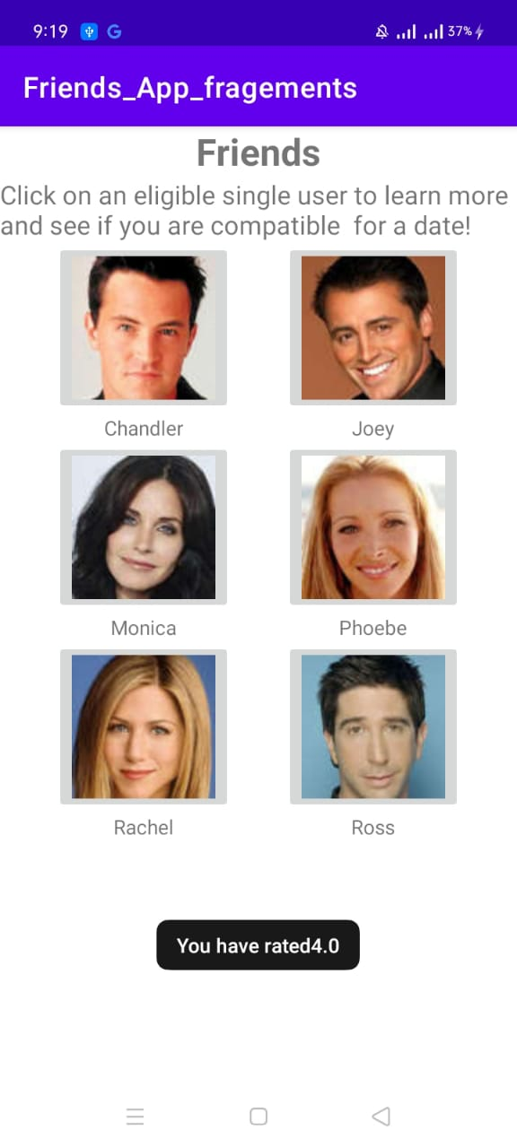

# Activity 4: Fake Twitter

## **Layout**

<?xml version="1.0" encoding="utf-8"?>

<androidx.constraintlayout.widget.ConstraintLayout xmlns:android="http://schemas.android.com/apk/res/android"

    xmlns:app="http://schemas.android.com/apk/res-auto"

    xmlns:tools="http://schemas.android.com/tools"

    android:layout_width="match_parent"

    android:layout_height="match_parent"

    tools:context=".MainActivity">

<FrameLayout

    android:layout_width="match_parent"

    android:layout_height="match_parent"

    android:id="@+id/fragement"

    ></FrameLayout>

</androidx.constraintlayout.widget.ConstraintLayout>

<?xml version="1.0" encoding="utf-8"?>

<FrameLayout xmlns:android="http://schemas.android.com/apk/res/android"

    xmlns:tools="http://schemas.android.com/tools"

    android:layout_width="match_parent"

    android:layout_height="match_parent"

    tools:context=".Details">

    <ListView

        android:layout_width="match_parent"

        android:layout_height="match_parent"

        android:id="@+id/details_list"

        ></ListView>

</FrameLayout>

<?xml version="1.0" encoding="utf-8"?>

<FrameLayout xmlns:android="http://schemas.android.com/apk/res/android"

    xmlns:tools="http://schemas.android.com/tools"

    android:layout_width="match_parent"

    android:layout_height="match_parent"

    tools:context=".List">

<ListView

    android:layout_width="match_parent"

    android:layout_height="match_parent"

    android:id="@+id/list"

    ></ListView>

</FrameLayout>

## **Logic Code**

package com.example.fake_twitter;

import androidx.appcompat.app.AppCompatActivity;

import android.os.Bundle;

public class MainActivity extends AppCompatActivity {

    @Override

    protected void onCreate(Bundle savedInstanceState) {

        super.onCreate(savedInstanceState);

        setContentView(R.layout.activity_main);

        getSupportFragmentManager().beginTransaction().add(R.id.fragement,new List()).commit();

    }

}

package com.example.fake_twitter;

import android.os.Bundle;

import androidx.fragment.app.Fragment;

import android.view.LayoutInflater;

import android.view.View;

import android.view.ViewGroup;

import android.widget.AdapterView;

import android.widget.ArrayAdapter;

import android.widget.ListAdapter;

import android.widget.ListView;

public class List extends Fragment {

    @Override

    public void onCreate(Bundle savedInstanceState) {

        super.onCreate(savedInstanceState);

    }

    @Override

    public View onCreateView(LayoutInflater inflater, ViewGroup container,

                             Bundle savedInstanceState) {

        ViewGroup view=(ViewGroup)inflater.inflate(R.layout.fragment_list,container,false);

        String names[]={"Bill Gates","Mark Zuckerburg", "Elon Musk"};

        ListView list=view.findViewById(R.id.list);

        ListAdapter Adapter=

      new ArrayAdapter<String>(getActivity(), android.R.layout.simple_list_item_1,names);

        list.setAdapter(Adapter);

      list.setOnItemClickListener(new AdapterView.OnItemClickListener() {

          @Override

          public void onItemClick(AdapterView<?> parent, View view, int position, long id) {

              Details details_frag=new Details();

              Bundle bundle=new Bundle();

              bundle.putString("name",names[position]);

              details_frag.setArguments(bundle);

              getFragmentManager().beginTransaction().replace(R.id.fragement,details_frag).commit();

          }

      });

        return view;

    }

}

package com.example.fake_twitter;

import android.os.Bundle;

import androidx.fragment.app.Fragment;

import android.view.KeyEvent;

import android.view.LayoutInflater;

import android.view.View;

import android.view.ViewGroup;

import android.widget.ArrayAdapter;

import android.widget.ListAdapter;

import android.widget.ListView;

public class Details extends Fragment {

    @Override

    public void onCreate(Bundle savedInstanceState) {

        super.onCreate(savedInstanceState);

    }

    @Override

    public View onCreateView(LayoutInflater inflater, ViewGroup container,

                             Bundle savedInstanceState) {

        ViewGroup view=(ViewGroup)inflater.inflate(R.layout.fragment_details,container,false);

        String name=getArguments().getString("name");

        String[] tweets;

        if(name.equals("Bill Gates"))

          tweets=view.getResources().getStringArray(R.array.billgates);

        else if(name.equals("Mark Zuckerburg"))

             tweets=view.getResources().getStringArray(R.array.Mark);

        else

            tweets=view.getResources().getStringArray(R.array.elon);

        ListView list=view.findViewById(R.id.details_list);

        ListAdapter Adapter=

                new ArrayAdapter<String>(getActivity(), android.R.layout.simple_list_item_1,tweets);

        list.setAdapter(Adapter);

        view.setFocusableInTouchMode(true);

        view.requestFocus();

        view.setOnKeyListener(new View.OnKeyListener() {

            @Override

            public boolean onKey(View v, int keyCode, KeyEvent event) {

                if (keyCode == KeyEvent.KEYCODE_BACK && event.getAction() == KeyEvent.ACTION_UP) {

                    getFragmentManager().beginTransaction().replace(R.id.fragement,new List()).commit();

                    return true;

                }

                return  false;

            }

        });

        return  view;

    }

}

## **Output**

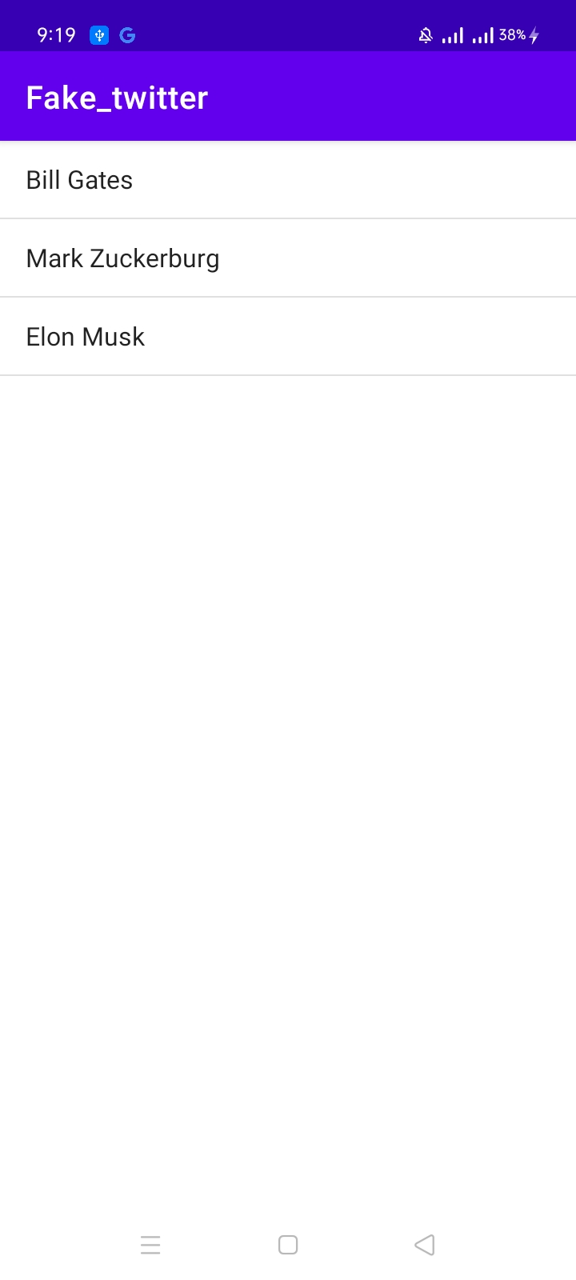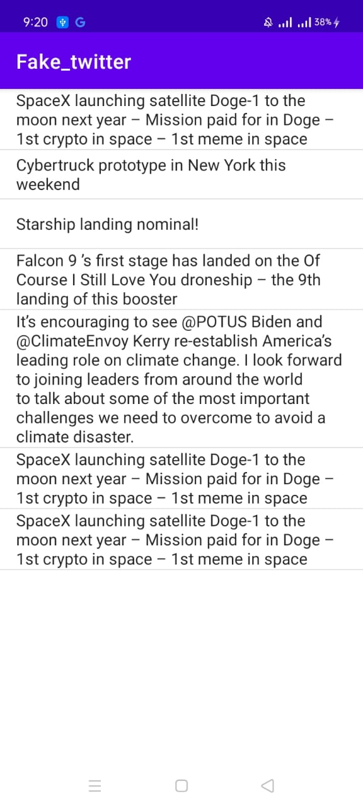

# Activity 5: Hangman (Speak to text and text to speech feature)

## **Layout**

<?xml version="1.0" encoding="utf-8"?>

<LinearLayout xmlns:android="http://schemas.android.com/apk/res/android"

    xmlns:app="http://schemas.android.com/apk/res-auto"

    xmlns:tools="http://schemas.android.com/tools"

    android:layout_width="match_parent"

    android:layout_height="match_parent"

    android:orientation="vertical"

    tools:context=".MainActivity">

    <TextView

        android:layout_width="wrap_content"

        android:layout_height="wrap_content"

        android:layout_gravity="center"

        android:text="Hangman"

        android:textSize="36sp"

        />

    <LinearLayout

        android:layout_width="match_parent"

        android:layout_height="wrap_content"

        android:orientation="horizontal">

        <ImageView

            android:id="@+id/img"

            android:layout_width="0dp"

            android:layout_height="150dp"

            android:layout_weight="1"

            app:srcCompat="@drawable/hangman0" />

        <LinearLayout

            android:layout_width="0dp"

            android:layout_height="match_parent"

            android:layout_weight="2"

            android:orientation="vertical">

            <TextView

                android:id="@+id/textView5"

                android:layout_width="match_parent"

                android:layout_height="wrap_content"

                android:text="The word:"

                android:textSize="24sp" />

            <TextView

                android:id="@+id/wordview"

                android:layout_width="match_parent"

                android:layout_height="match_parent"

                android:text="TextView"

                android:textSize="30sp" />

        </LinearLayout>

    </LinearLayout>

    <LinearLayout

        android:layout_width="match_parent"

        android:layout_height="wrap_content"

        android:orientation="horizontal"

        >

        <EditText

            android:id="@+id/txt"

            android:layout_width="0dp"

            android:layout_height="wrap_content"

            android:layout_weight="1"

            android:maxLength="1"

            android:lines="1"

            android:maxLines="1"

            android:inputType="textPersonName"

            android:layout_marginLeft="10dp"

            />

        <Button

            android:id="@+id/guess"

            android:layout_width="0dp"

            android:layout_height="wrap_content"

            android:layout_weight="1"

            android:onClick="Guessword"

            android:text="Guess"

            android:layout_marginLeft="5dp"

            />

        <Button

            android:id="@+id/speak"

            android:layout_width="0dp"

            android:layout_height="wrap_content"

            android:layout_weight="1"

            android:onClick="recognizer"

            android:text="speak"

            android:layout_marginLeft="5dp"

            />

        <Button

            android:id="@+id/New"

            android:layout_width="0dp"

            android:layout_height="wrap_content"

            android:layout_weight="1"

            android:onClick="newWord"

            android:text="NEW"

            android:layout_marginLeft="5dp"

            />

    </LinearLayout>

    <TextView

        android:id="@+id/guessview"

        android:layout_width="wrap_content"

        android:layout_height="wrap_content"

        android:layout_gravity="center"

        android:text="You have guessed "

        android:textSize="15sp" />

</LinearLayout>

## **Logic Code**

package com.example.hangman;

import androidx.annotation.Nullable;

import androidx.annotation.RequiresApi;

import androidx.appcompat.app.AppCompatActivity;

import android.content.Intent;

import android.graphics.drawable.Drawable;

import android.os.Build;

import android.os.Bundle;

import android.speech.RecognizerIntent;

import android.speech.tts.TextToSpeech;

import android.util.Log;

import android.view.View;

import android.widget.Button;

import android.widget.EditText;

import android.widget.ImageView;

import android.widget.TextView;

import android.widget.Toast;

import java.util.ArrayList;

import java.util.Locale;

import java.util.Random;

public class MainActivity extends AppCompatActivity {

    String word;

    TextView guessedword;

    EditText txt;

    ImageView img1;

    String[] imgaddr;

    int imgnum;

    Random rand;

    String guessedwords;

    TextView guessview;

    Button guessBtn;

    Button NewBtn;

    TextToSpeech tts;

    @Override

    protected void onCreate(Bundle savedInstanceState) {

        super.onCreate(savedInstanceState);

        setContentView(R.layout.activity_main);

        rand=new Random();

        word=getResources().getStringArray(R.array.words)[rand.nextInt(5441)];

        Log.i("word",word);

        guessedword=(TextView)findViewById(R.id.wordview);

        guessedword.setText(word.replaceAll(".","?"));

        guessview=(TextView)findViewById(R.id.guessview);

        guessBtn=(Button)findViewById(R.id.guess);

        NewBtn=(Button)findViewById(R.id.New);

        imgaddr= new String[]{

                "@drawable/hangman6",

                "@drawable/hangman5",

                "@drawable/hangman4",

                "@drawable/hangman3",

                "@drawable/hangman2",

                "@drawable/hangman1",

                "@drawable/hangman0"};

        imgnum=0;

        guessedwords="";

    }

    public void Guessword(View view){

        txt=(EditText)findViewById(R.id.txt);

        char[] temp=guessedword.getText().toString().toCharArray();

        if(guessedwords.contains(txt.getText().toString())) {

            Toast.makeText(this,"Already entered",Toast.LENGTH_LONG).show();

            txt.setText("");

            return;

        }

        boolean check=true;

        for(int i=0;i<word.length();i++) {

            if (word.charAt(i) == txt.getText().charAt(0)) {

                temp[i] = word.charAt(i);

                check = false;

            }

        }

        String str=new String(temp);

        guessedword.setText(str);

        if(str.equals(word)) {

            Toast.makeText(this, "You win", Toast.LENGTH_LONG).show();

            guessBtn.setEnabled(false);

            return;

        }

        if(check){

            if(++imgnum>=7) {

                tts = new TextToSpeech(this, new TextToSpeech.OnInitListener() {

                    @RequiresApi(api = Build.VERSION_CODES.LOLLIPOP)

                    @Override

                    public void onInit(int status) {

                        tts.speak("Game over", TextToSpeech.QUEUE_FLUSH, null, "1234");

                    }

                });

                guessBtn.setEnabled(false);

                guessview.setText("Game over word was "+word);

                return;

            }

        }

        guessedwords+=txt.getText().toString();

        String message=(7-(imgnum))+" guesses left";

        tts = new TextToSpeech(this, new TextToSpeech.OnInitListener() {

            @RequiresApi(api = Build.VERSION_CODES.LOLLIPOP)

            @Override

            public void onInit(int status) {

                tts.speak(message, TextToSpeech.QUEUE_FLUSH, null, "1234");

            }

        });

        guessview.setText("You have guessed :"+guessedwords+"("+message+")");

        txt.setText("");

        int imageResource = getResources().getIdentifier(imgaddr[imgnum], null, getPackageName());

        img1= (ImageView)findViewById(R.id.img);

        Drawable res = getResources().getDrawable(imageResource);

        img1.setImageDrawable(res);

    }

    public void newWord(View view){

        guessBtn.setEnabled(true);

        guessview.setText("You have guessed : ");

        word=getResources().getStringArray(R.array.words)[rand.nextInt(5441)];

        guessedword.setText(word.replaceAll(".","?"));

        img1.setImageResource(R.drawable.hangman6);

        imgnum=0;

        guessedwords="";

    }

    public void recognizer(View view) {

        Intent intent = new Intent(RecognizerIntent.ACTION_RECOGNIZE_SPEECH);

        intent.putExtra(RecognizerIntent.EXTRA_LANGUAGE, Locale.getDefault());

        intent.putExtra(RecognizerIntent.EXTRA_LANGUAGE_MODEL, RecognizerIntent.LANGUAGE_MODEL_FREE_FORM);

        intent.putExtra(RecognizerIntent.EXTRA_PROMPT, "Speak the single letter");

        startActivityForResult(intent, 1234);

    }

    @Override

    protected void onActivityResult(int requestCode, int resultCode, @Nullable Intent data) {

        super.onActivityResult(requestCode, resultCode, data);

        ArrayList<String> list=data.getStringArrayListExtra(RecognizerIntent.EXTRA_RESULTS);

        txt=(EditText)findViewById(R.id.txt);

        txt.setText(list.get(0));

    }

}

## **Output**

